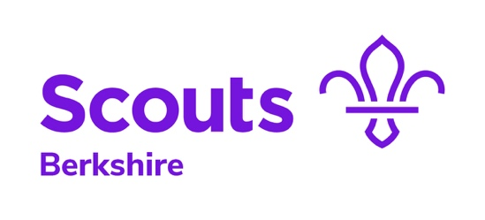

Good Service Awards – draft content

The purpose of this document is to capture the draft content for a good service award nomination prior to a final submission online. The document enables the content to be shared between nominator and supporter/approver before being copied/pasted to the online form.

Note: when an online form is submitted it cannot be changed or edited (under review).

Name/nominee:

Membership number:

Good Service Award:

Name/nominator:

Note: the online form requires more details of the nominee and nominator. The additional details can be added directly to the online form at the copying/pasting stage.

Main role in Scouts
Outline what this role involves and the time commitment the nominee puts in. Please limit your response to 10000 characters or less.

Service in addition to their main role in Scouts
Outline what's involved in any other roles in Scouts and the time commitment the nominee puts in. Please limit your response to 10000 characters or less.

Key achievements
Outline specific achievements and impact of the nominee since their last Good Service Award (if they have one). Examples could include how they’ve: helped grow membership, raised funds, managed large projects or rebuilt their headquarters, etc. Please quote specific figures where possible and limit your response to 10000 characters or less.

Level of service
Where a previous Good Service Award is held, please outline whether the nominee has continued to provide service at a similar level or whether you believe the quality/complexity of their service has substantially increased and why. Please limit your response to 10000 characters or less.

Community involvement
Outline any involvement that the nominee has with other organisations since their last Good Service Award. Highlight if this involvement has directly benefitted Scouts. Please limit your response to 10000 characters or less.

Any other relevant information

Citation
Summarise why the member is deserving of this award. This information can then be read out when the award is presented but will also appear on the member’s profile against the award.

This draft content form has been created by the Berkshire Scouts Awards sub-team to support nominators in creating content to help meet the full criteria for the award.

For further information:
Mick Stocks (Lead – Awards sub-team)
mick.stocks@berkshirescouts.org.uk

