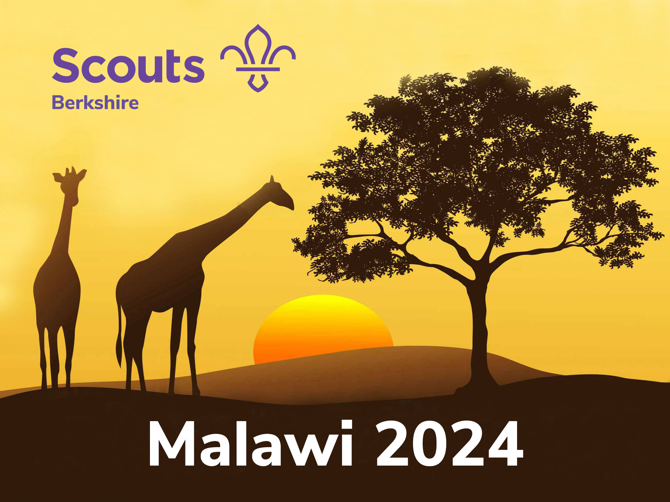 | 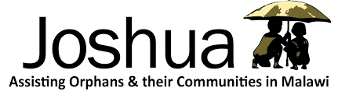 | 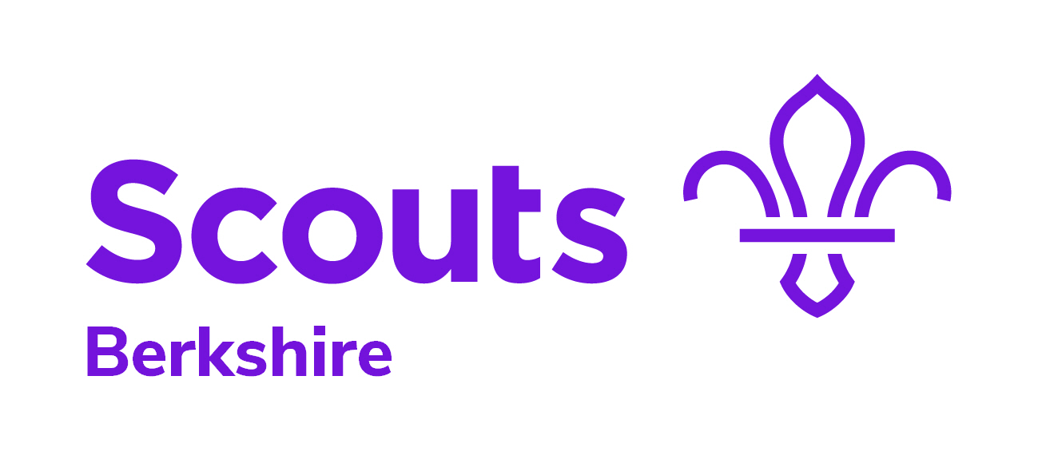

Berkshire Scouts registered charity no: 1015269
Sindlesham Court office: 0118 228 2958
Mole Road, Sindlesham
Wokingham, Berkshire RG41 5EA [date]

To whom it may concern

This letter is to confirm that [name] is taking part in a Berkshire Scouts international community project to be held in Malawi during July–August 2024.

The projects in Malawi are part of a Berkshire Scouts educational programme supporting young people, mainly through building a new community centre in the village of Milo as well as refurbishing other local community buildings.

Berkshire Scouts are partnering with the British charity, Joshua in Malawi. The charity will be providing the project sites together with local builders and other support.
www.joshuainmalawi.org.uk/

Further information about Berkshire Scouts and Malawi 2024 is available at:
https://www.berkshirescouts.org.uk/project-africa-2024

In order for [name] to take a safe and active part in the project there is a training programme that participants must take part in. This includes three residential/camping weekends and a number of day sessions/workshops during 2023 and 2024.

The cost for [name] to take part in the project is £3,750. This includes the training programme; travel; insurance; food; central equipment; and cultural activities (getting to know Malawi). Inoculations and personal equipment are additional costs.

We hope you are in a position to support [name] in being part of this special and life-changing international experience. We will be more than happy to provide any further information if required.

Yours sincerely,
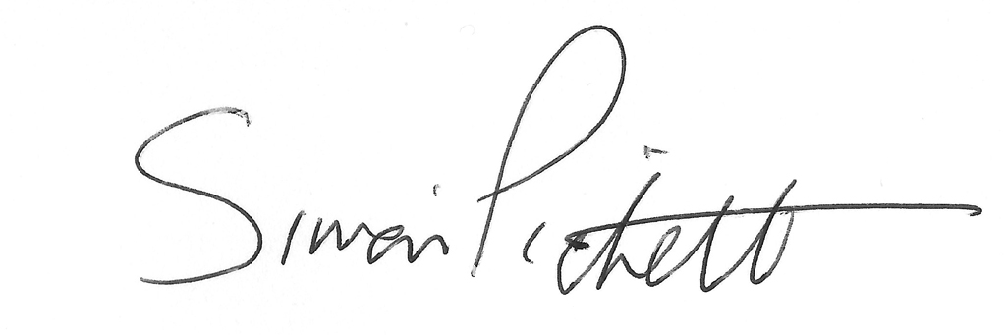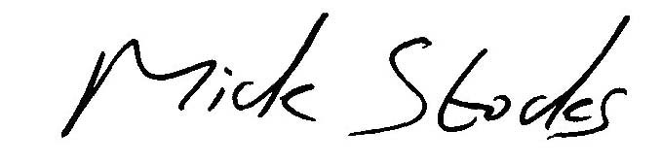
Simon Pickett Mick Stocks, MBE
Leader: Project Africa 2024 Chair: Project Africa

email contact: africa2024@berkshirescouts.org.uk

Berkshire Scouts | enabling young people to explore their worlds

