Scouting in….Germany |  |  | Scouting in….Canada |  |  | Scouting in….Norway |  |  | Scouting in….Brazil |  |  | Scouting in….Japan
 |  |  | 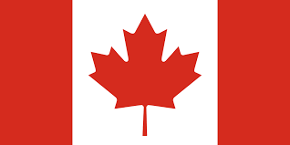 |  |  | 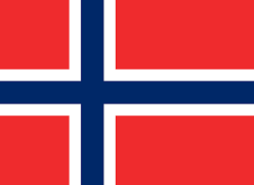 |  |  | 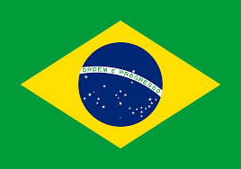 |  |  | 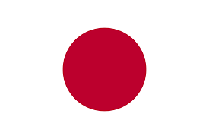
When did it start? | 1909 |  | When did it start? | 1914 |  | When did it start? | 1978 |  | When did it start? | 1924 |  | When did it start? | 1922
How many members do they have? | 260,000 |  | How many members do they have? | 83000 |  | How many members do they have? | 18,500 |  | How many members do they have? | 100,000 |  | How many members do they have? | 99,779
Interesting Fact | There are 120 Boy Scouts of America troops on Military Bases |  | Interesting Fact | Tamaracout Scout reserve is one of the oldest scout camps in the world. |  | Interesting Fact | Scouts stay in section until 16 years old |  | Interesting Fact | 3000 attended the 1998 World Scout Jamboree |  | Interesting Fact | Scouts in Japan also learn how to be ninjas

Scouting in….Pakistan |  |  | Scouting in….South Africa |  |  | Scouting in….Thailand |  |  | Scouting in….America |  |  | Scouting in….Poland
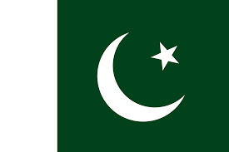 |  |  | 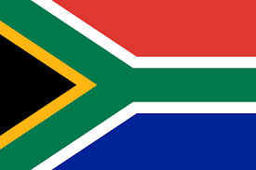 |  |  | 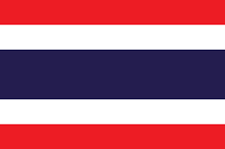 |  |  | 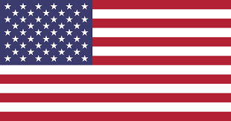
When did it start? | 1947 |  | When did it start? | 1908 |  | When did it start? | 1911 |  | When did it start? | 1910 |  | When did it start? | 1918
How many members do they have? | 710,202 |  | How many members do they have? | 299,128 |  | How many members do they have? | 828,248 |  | How many members do they have? | 2,740,866 |  | How many members do they have? | 138,122
Interesting Fact | PBSA was founded after independence from Britain |  | Interesting Fact | highest award is springbok award. Must be complete by age 18 |  | Interesting Fact | Their Scout motto is  “Better to die than to lie “ |  | Interesting Fact | Order of the arrow is a special group for those with Native American Camping skills |  | Interesting Fact | The Scout Motto is "Czuwaj", translating literally as "stay awake"

Scouting in….United Kingdom |  |  | Scouting in….Australia |  |  | Scouting in….Hong Kong |  |  | Scouting in….Indonesia |  |  | Scouting in….France
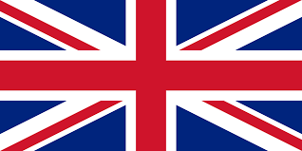 |  |  | 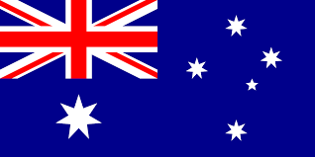 |  |  | 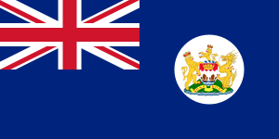 |  |  |  |  |  | 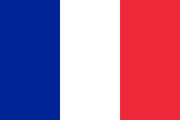
When did it start? | 1907 |  | When did it start? | 1958 |  | When did it start? | 1977 |  | When did it start? | 1961 |  | When did it start? | 1920
How many members do they have? | 457,173 |  | How many members do they have? | 51,228 |  | How many members do they have? | 95,877 |  | How many members do they have? | 17,103,793 |  | How many members do they have? | 68,221
Interesting Fact | Beaver Scouts were introduced in 1986 |  | Interesting Fact | Beavers in Australia are called Joeys |  | Interesting Fact | They are the only legal scout group in China |  | Interesting Fact | Indonesian scouting was founded by Dutch scouts |  | Interesting Fact | Scouts and Guides are in the same group

