|  |
| --- |
| **Tried & Tested Scout programmes**  **Amber – 3: Simple Cooking on a Backpacking Stove**    **Don’t forget to complete your written risk assessments** |

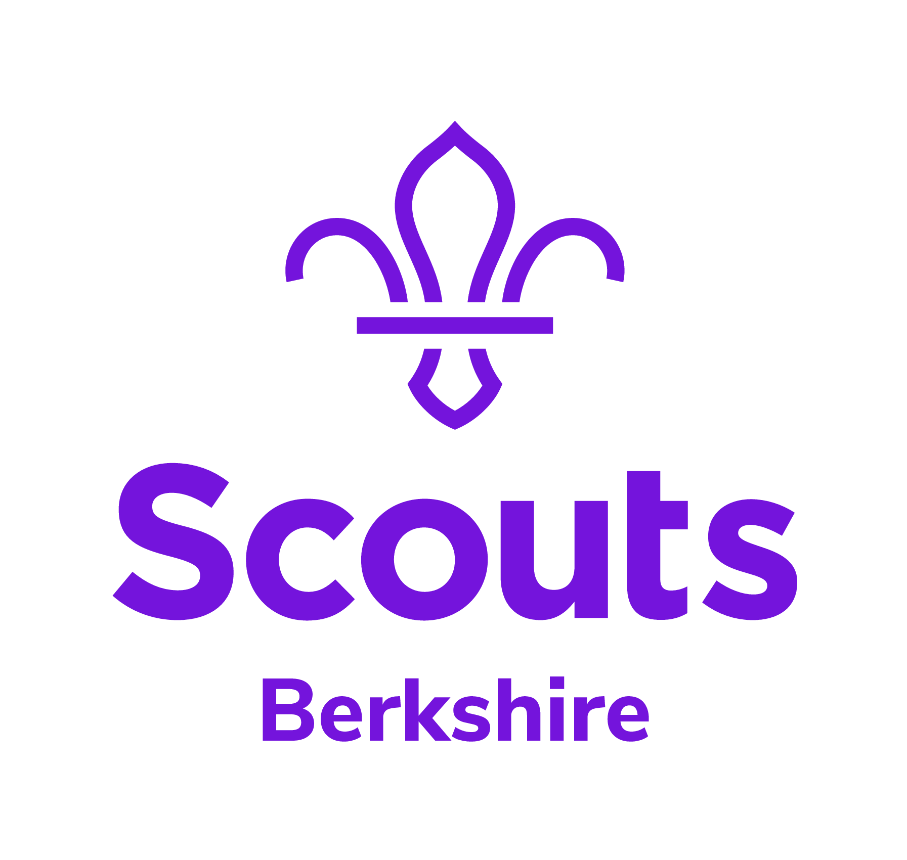

|  |  |  |  |  |  |
| --- | --- | --- | --- | --- | --- |
| **Activity** | **Description** | **Preparation/equipment** | **Some thoughts for your Risk Assessment** | **@home challenge element**  <https://www.berkshirescouts.org.uk/scoutshome/> | **Time** |
| Arrival | Welcome the Scouts and ensure they clean their hands. When all have arrived, escort them to their activity area | None | Agree your arrival plans with parents |  | 5 mins |
| Opening | Brief distanced Horseshoe Ceremony and demonstration of safe use of the backpacking stove … stressing the risks of the invisible flame, etc. Their challenge is to cook themselves a noodle meal and a cup of hot chocolate. | Backpacking stove to demonstrate | Keep 2m apart and dispense with flag break and saluting? |  | 5 mins |
| Cooking on the Stove | Make your own Pot a Soup a Cup a Noodle…  As well as the equipment issued to every Scout there is a selection of cup soups available. Scouts mix a cup soup with the noodles to make their own meal. Scouts must choose the soup packet quickly and clearly – once they have touched it they cannot change their mind.  As well as the kit issued to each Scout and the soup, you need some central kit: Extra water, meths, matches, fire bucket (full of water) for burns, handwashing table, water, basin, hand soap, paper towels, binbag for used towels.  Leaders collect in the stoves, mugs, spoons, etc, at the end to ensure thorough cleaning | Each Scout has in a pile:   * Stove * Fuel for stove (or this can be poured in when needed by a leader) * Full water bottle * Matches or lighter * One portion quick cook noodles * One portion hot chocolate * Small mug and spoon for chocolate * Large mug and spoon for noodles | Hands to be washed before preparing both courses in the mugs | Learn a new skill | 60 mins |
| Game | If there is time available, do a quick active game since they have not moved a lot during the meeting, eg: kick rounders, or a manhunt game where they just need to call the name of the person to show that they have found them | None | Ensure boundary of game is clear |  | 15 mins |
| Closing | Quick reflection discussion: What’s it like to be doing this sort of activity by yourself? What other things could you cook on one of the stoves? If they were using these stoves on an Expedition challenge, what food would they take? Escort Scouts back to pick up point | None | Ensure on time finish so that groups don’t meet other groups on departure |  | 5 mins |

Berkshire Scouts/Andrew Sutherland July 2020