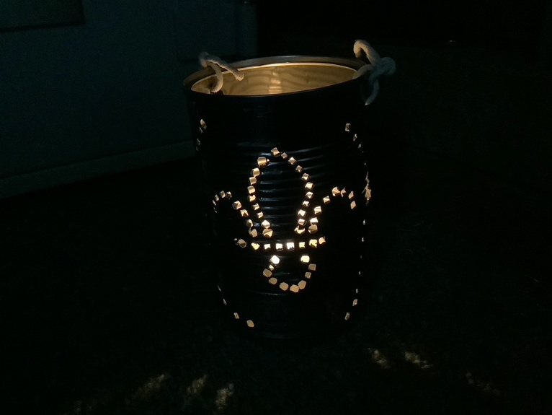
Equipment needed: (brief them about this in advance)
Postcard or similar sized piece of paper or card
Scissors
Pole, approx. 1.5m long
Tin can filled with water and frozen in advance
Nail (minimum 5cm, maximum 10cm)…
Towel to rest tin can on
Hammer
One sheet of paper and sticky tape and pen.
Printouts of any logos they want on their lanterns
Candle or tea light
Matches
String or wire to hang lantern

Activity | Description | Preparation/  equipment | Some things to consider for your Risk Assessment | @home challenge element  https://www.berkshirescouts.org.uk/scoutshome/ | Time
Welcome | Give a few minutes for Scouts to combat any technical difficulties and join the Zoom call. Share the kit list for the meeting in the Chat window so they can chase up any key elements they are missing. If any Scouts have joined since the whole Troop was last together, introduce them to the Troop. | Send out video connection instructions in advance | Follow good practice for video meetings, eg: keeping youth attendees in waiting room until 2 adults present |  | 5 mins
First Challenge | The Scout Staff Challenge: This challenge is easier with shoes off. Do some stretches before starting. Clasp a scout staff horizontally in front of you, palms upwards. Without letting go of the pole climb over it, bring it up behind your back, over your head and down in front of you. At this point your hands should be twisted outwards. Without taking your hands off the pole (you can slide your hands along it) lift your right leg round the outside of your right arm and down between your arms. This is the most difficult part and you will find it easier if you keep your hands near together. Slide your hands along the pole as wide apart as you can, bring it up past your right knee, over your head and down your back. Step through it and you should be back in your original position. | Each Scout needs a staff, pole, broom handle, etc of around 1.5m. | Inflexible older attendees (ie: leaders) doing themselves a mischief attempting silly contortions |  | 10 mins
Second Challenge | Walk Through a Postcard: Find the file ‘Walk Through a Postcard’, posted by Dave Wood on the 1st Virtual Facebook Group, for an explanation of this activity. Scouts need to make a hole in a postcard big enough to walk through | Postcard sized piece of paper or card. Scissors | Standard scissors risks apply… don’t cut towards the finger of your other hand |  | 10 mins
Troop Forum | Whole Troop Discussions: what discussions do you need to have as a Troop? With all your groups together for a video meeting, this is a good time to have them. Some Scouts may be nervous about talking to the whole video meeting so encourage use of the chat window to make their inputs to the discussion. |  |  |  | 10 mins
Tin Can Lantern Making | Tin Can Lantern: They need to fill a can with water and freeze it in advance. Sketch a design on paper and tape it to the can. Bold, simple designs are best. You could send out a copy of the Scout logo at the right size for a can. Tap holes through with a hammer and nail (watching fingers!) with the gap between holes at least as wide as the holes or they can tear through. Don’t forget to put in a couple of hanging holes near the top of the can. Put in hot water to melt the ice. Put in tea light, light the lantern, turn the lights off and show the Troop what you have made.  PS: The point of the ice is that it holds the sides of the can firm when you are bashing it with nails. It stops the can from crumpling and makes the holes neater. | Tin can filled with ice, nail, hammer, towel,  Paper, sticky tape, pen. Printouts of any logos they want on their lanterns. Candle or tea light. Matches. String or wire to hang lantern | Be careful when tapping in holes on the ridges that run horizontally along a tin can since the nail can slip. When in use, the sides of the lantern can get a little bit hot. Be careful lighting the lantern since the holes have sharp edges pointing inwards. Use a long match or lighter if you have one. | Learning new skills | 30 minutes
Closing | Arrangements for the next Troop meeting |  |  |  | 5 mins

Covid Safety is maintained by running the meeting via video.

Berkshire Scouts/Andrew Sutherland October 2020

