Activity | Description | Preparation/equipment | Some things to consider for your Risk Assessment | @home challenge element  https://www.berkshirescouts.org.uk/scoutshome/ | Time
Arrival | Welcome the Scouts and ensure they clean their hands. When the group has arrived, escort them to their activity area | None | Agree arrival plans with parents |  | 5 mins
Opening | Brief distanced Horseshoe Ceremony and explanation of the Cane Pioneering Challenge | Demonstrate equipment available | Keep distanced and dispense with flag and saluting? |  | 5 mins
Cane Pioneering Ballista Challenge | See handout | See detailed notes below |  | Learn a new skill | 60 minutes
Marshmallow Toasting | Depending on how the Scouts are getting on with building their ballistas, the long marshmallow toasting sticks can be manufactured out of canes by the scouts or (to speed things up) by the leaders. Fire or barbecue needs to be lit 45 minutes into the Scout construction project to be ready for toasting. Scouts to wash hands before and after the marshmallow cooking. |  |  |  | 15 mins
Closing | Quick reflection discussion: could we improve our social distancing in future meetings? Escort Scouts back to pick up point |  | Risk: Mixing with other groups… ensure no lift sharing between groups. Ensure all groups finish their sessions on time |  | 5 mins

Cane Pioneering – Socially Distanced Scout Evening

Scouts build their own design of a garden cane ballista, trebuchet, javelin launcher or catapult and compete to see who can launch a ball the furthest. Then they make a long marshmallow toasting stick (and cook marshmallows on a central fire). 90 minute session.

CANE PIONEERING SOLO BALLISTAS, TREBUCHETS, CATAPULTS AND JAVELIN LAUNCHERS: Scouts pick their own design to build (see pictures below for ideas)
Looked out for each Scout:
- 8 or 9 canes or wooden staves or broom handles,
- A length of string and a knife or scissors to cut it with,
- 6 metal or wooden pegs (plus mallet for wooden ones) to attach structures to the ground
- A small ball or stone to fire out of the device… tennis ball max size (coconut shy balls are perfect)
- 1 metre length of thick elastic, eg: 24mm Flat Waistband Sewing Elastic
- One wooden skewer for the marshmallow toasting in the second activity
- Printout of the design ideas

Centrally available: additional kit: lots of choice… scouts can come up one by one to pick what they need. All provided on a ‘you touch it – you take it’ basis. If tools are used, eg: to cut things up, they should be cleaned with antibacterial spray between use.
- More string / sisal / canes / elastic cord
- Various plastic pots, etc, from the recycling, for catapult pouches
- Parcel tape or electrical tape for covering knots in elastic to stop them unravelling or for strengthening the rims of pots before putting holes in them.
- Leather scraps with pre made holes in for sling shot pouches
- Parcel tape, electrical tape for covering knots in elastic to stop them unravelling
- Tools to make holes in them (big nails, scissors, etc)
- Antibacterial spray, cloths and a bin bag in case of reuse of tools

The design below is larger than life size for canes, but a good design.

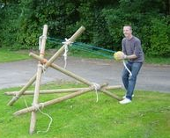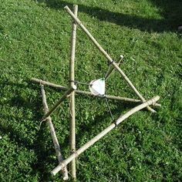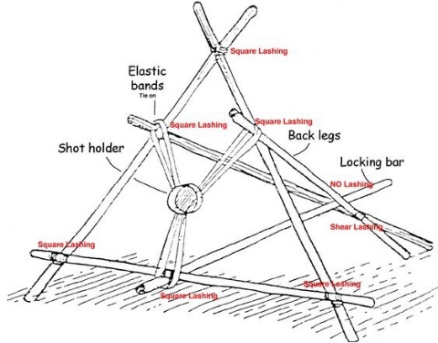

Could also launch a javelin through the V at the top with elastic attached inside the V

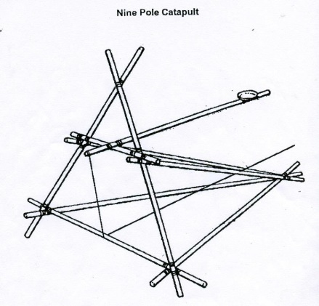

Each Scout needs to build their own structure. Whichever design they pick the aim of the exercise is distance – how far does the projected item go.

Long Marshmallow sticks: Scouts are spread out around a fire, socially distancing. The problem is that they are too far away from the fire to cook their marshmallows. Using canes they need to build a long toasting stick. The final length of the stick should be a wooden barbecue skewer rather than a garden cane and should be attached with sisal / string (not an elastic band and not plastic string…don’t want burned plastic near food). Scouts take it in turns to step up towards the fire (there will be a limit to the number who can toast at once, even with very long sticks)

Kit For the Marshmallow Toasting:
Add fire tray, barbecue, dig a fire pit, etc.
lighter,
kindling,
paper,
woodpile (look out before Scouts get there)
Fire bucket, filled with water
Saw,
Bricks to balance fire tray on.
Wooden skewers for making the toasting spikes at the end of their canes
Small bags made up with five marshmallows each

For handwashing before and after the marshmallow toasting: (and for generally keeping things clean and safe)
Handwashing table,
Basin
Hand soap
Paper towels in a box or pot to stop them blowing around and to keep them dry
Binbags
Jay cloths
Antibacterial cleaning spray
First Aid kit
PPE kit

Covid Safety is maintained by:
- Scouts reminded of the rules at the start of the activity
- This activity group must keep completely separate from any other groups on site
- Each Scout works separately on the activities
- Each Scout has their own set of equipment
- Hand washing is in place at the start and before and after the cooking
- Leaders encouraged to coach from a distance and not intervene directly in the completion of the task

Additional risk management considerations:
- The firing direction of each contraption must point away from everybody else, especially if a design involves firing a cane like a javelin rather than firing the ball.
- Any scout wanting to use a knife, eg: to make holes in a pot to make a cradle for the ball, needs to do so in a central area. One knife per Scout (or clean between uses). A leader needs to supervise this directly to check that the scout is following good practice for knifework
The area needs to be litter swept after the activity to check that no sharp items are left lying around

Berkshire Scouts/Andrew Sutherland July 2020

