|  |
| --- |
|  |

|  |  |  |  |  |  |
| --- | --- | --- | --- | --- | --- |
| **Activity** | **Description** | **Preparation/ equipment** | **Some things to think about for your Risk Assessment** | **@home challenge element** <https://www.berkshirescouts.org.uk/scoutshome/> | **Time** |
| Arrival | Welcome the Scouts and ensure they clean their hands. When the group has arrived, escort them to their activity area | None | Agree arrival arrangements with parents |  | 5 mins |
| Opening | Brief distanced Horseshoe Ceremony and explanation of the Bean Can Burners | Demonstrate kit available | 2m distancing. Dispense with flag and saluting?  Reminder about distancing rules |  | 5 mins |
| Bean Can burner | Cooking bacon or cheese bites on the top of a tin can, with the heat of a candle underneath. Tin can needs holes in it for ventilation. Scouts need to find a suitable, flat, distanced piece of ground to put their burner on, then one at a time come to cut their candle down to size under leader supervision. They cook their food over the burners. At the end they ensure the candle is properly out | See detailed notes below | | Learn a new skill | 30 mins |
| Frisbee Golf | Throwing a frisbee through a series of hoops set up on the site (away from any other site users) Scouts start off one at a time but are making up their own route round the hoops so need to respect distance from others. Aim is to complete the whole course with as few throws as possible. | Learn a new skill | 20 mins |
| Socially Distanced Sports Day | A set of sports challenges that can be done without getting close to others or sharing any equipment |  | 25 mins |
| Closing | Quick reflection discussion: What else could we cook on the burners in future? What other Sports Day games can they think up? Escort Scouts back to pick up point | None | Risk: Mixing with other groups… ensure no lift sharing between groups. Ensure all groups finish their sessions on time |  | 5 mins |

Berkshire Scouts/Andrew Sutherland July 2020

**BEAN CAN BURNERS AND FRISBEE GOLF:**

**90 MINUTE SCOUT SOCIALLY DISTANT SESSION**

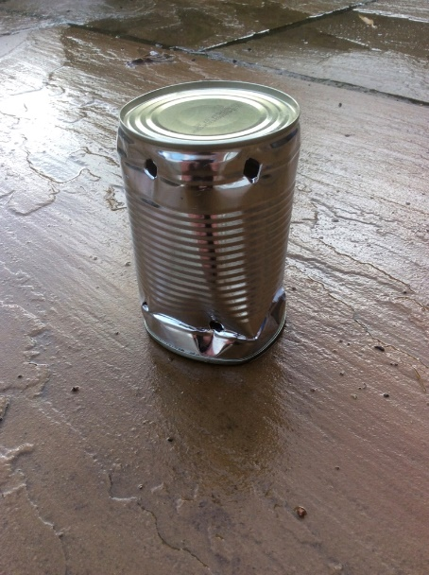

**You light a candle under the burner and it heats the top surface enough to cook small bits of bacon or halloumi cheese. Each Scout has their own kit and is spread out from the others.**

**Kit per Scout**

Bean can burner - one per person – holes already in them

Candle

Knife (they cut the candle to size themselves, one at a time, under leader supervision)

Box of matches

Small canister of cooking oil (for cooking the cheese)- eg: old film canisters

1 or 2 cocktail sticks

Wooden tentpeg to make hole in ground for candle

Oven glove

Bacon Lardons or cut up bacon bits

Halloumi cubes (veggie option)

Bacon pots can have some cheese mixed in too

About 20 little cubes of food per person is enough

**For handwashing before and after the food prep activity: (and for generally keeping things clean and safe)**

Handwashing table,

Basin

Hand soap

Paper towels in a box or pot to stop them blowing around and to keep them dry

Binbags

Jay cloths

Antibacterial cleaning spray

First Aid kit

PPE kit

Bucket of water for burned fingers!

Spare candles

**Frisbee Golf:** Kit: one frisbee per person, 7 or 8 hula hoops, string to tie hoops to trees (stakes, etc, to tie hoops to if trees not available. Set up a series of hoops around the area. Every player has a frisbee (they are easy to clean between goes if you need to share). Players plan their own route around the course, keeping away from others and trying to minimise the number of throws it takes them to get the frisbee through all the hoops. Players have two goes. On the second round they focus on beating their first round score. Players get a point added onto their score for any social distancing breach observed by a leader

**Hands Off Sports Day:** sports day games formats can have a lot less physical contact than many of the games Scouts usually play and can have reduced equipment. Eg:

Shoe Putting… Who can throw the furthest? Hop to where it landed to put it on again. A leader moves a tent peg to the furthest landing point so that players can see the distance to beat. Hopping, All 4s, Feet together (invisible sack race), Penguin walk, Limbo dancing, Three hops from standing start, Standing still long jump. Kit: A long starting line, (rope, pegs, mallet), small cones or peg to keep a record of the furthest distance achieved in an event.

**Covid Safety is maintained by:**

* Scouts reminded of the rules at the start of the activity
* This activity group must keep completely separate from any other groups on site
* Each Scout works separately on the cooking and the frisbee golf
* Each Scout has their own set of equipment
* Hand washing is in place before and after cooking
* Leaders encouraged to coach from a distance and not intervene directly in the completion of the task
* During the frisbee golf, when scouts will be crossing paths with others regularly, players need to focus as much on distancing as on the golf game

**Additional risk management considerations:**

* The bean can burners have sharp edges and get very hot. They should be handled with the oven gloves.