Activity | Description | Preparation/  equipment | Some things to consider for your Risk Assessment | @home challenge element  https://www.berkshirescouts.org.uk/scoutshome/ | Time
Welcome | Gather your group, take attendance, check they have cleaned their hands and take them to where you will be doing the activity.  If the group is up to about 8 run the evening as two sequential sessions with everybody doing the same thing at once.  If the group is over about 8 split them in two and run the sessions in parallel, swapping half way through. | Hand sanitiser | Running drop off and pick up as per the covid-safe RA for that location |  | 5 mins
Featherstick making | Each Scout needs their own area for knifework. Marking them out with a small groundsheet or sack is a useful way to keep the group safely separated and socially distanced, and to catch the chippings to dry out for tinder. Demonstrate safe use of the knife and how to make a featherstick. See photo below. Each cut comes from a slightly different angle so they don’t slice off the last frond of wood carved out  If Scouts finish their featherstick early they can go into the centre of the circle and get supervised by the leader cross splitting the next batons of wood (to make more during the session and to have some ready for the next group) – have a pile of batons ready  Cross-cutting a baton:  - Baton upright on ground.  - Held upright by blade of knife resting on top of it  - Knife held horizontal in non-dominant hand, with about a centimeter gap between the knife handle and the baton.  - Using another baton tap the knife on the top of the baton vigorously until it splits. Continue tapping the knife at the tip end (beyond the baton) as the blade slides through the baton. Repeat with the half batons. Make feather sticks out of quartered batons to get three good angled edges of wood to carve with  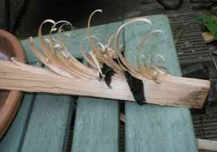 | Batons of green wood around 20cm long, split into quarters. One survival knife per Scout. Small groundsheet or sack per Scout. Antibacterial cleaner and cloths | Safe use of knives (always cutting away from your hands, steadying the stick by pressing it against the ground or a piece of flat wood)  Before the group moves on they clean the knives carefully with antibacterial spray if they are going to be used again that day. | Learning new skills | 40 minutes
Trap Making | Each Scout needs to make two trap designs. Some of these are from the highly recommended SAS Survival Handbook. Make up kits in advance so that each Scout only touches the equipment they need for the projects they have been allocated. They are either building traps or snares. For the detailed designs, see below. | See detailed trap instructions | Scouts to keep well back. Groups to keep in their own area. Trap designs would not be high risk to humans, eg: nooses too small for necks, no heavy dropping components or propelled sharp components  Before the group moves on they clean the kit carefully with antibacterial spray if its going to be used again that day. | Learning new skills | 40 mins
Closing | Return to pick up point. Ensure hands are cleaned. Run briefly through arrangements for the next Troop meeting |  |  |  | 5 mins

Covid Safety is maintained by:
- Scouts reminded of the rules at the start of the activity
- This activity group must keep completely separate from any other groups on site
- Each Scout works separately on the activities
- Each Scout has their own set of equipment
- Hand washing is in place at the start and before and after the cooking
- Leaders encouraged to coach from a distance and not intervene directly in the completion of the task
- If the two activities are run in parallel with groups swapping half way through then the equipment needs to be cleaned quickly with antibacterial spray.

Combination of Traps to build | Equipment: (a set of this per Scout)
Half the Scouts make the Cage Trap and Figure 4 trap | Wire Cage or Laundry Basket  Three pulleys  Three pre-made wooden components for the Figure 4 trap  Mallet  One tent peg for the Cage Trap wire to attach to  Laminated set of instructions
Half the Scouts make the Spring Snare and Roller Spring snare | In a bucket to stop it getting lost:  Two horseshoes as a weight to trigger the roller spring snare, or similar weight  One pulley  2 pieces of wire for snares, pre-cut (soft enough wire it can be shaped by hand)  Wire attached to pulley to stop it getting lost  Mallet  Cane cross piece for roller spring snare  Three large tent pegs and one small one whose top can interlock with a large one  Laminated set of instructions
Also available in each area: Antibacterial spray, cloths, binbag, plus something tied to the end of a stick, to trigger the traps when made

CAGE TRAP AND FIGURE 4 TRAP

CAGE TRAP: Trip wire triggers basket falling: Three pulleys, Tent peg, Mallet, String, Scissors, Laundry basket or wire cage

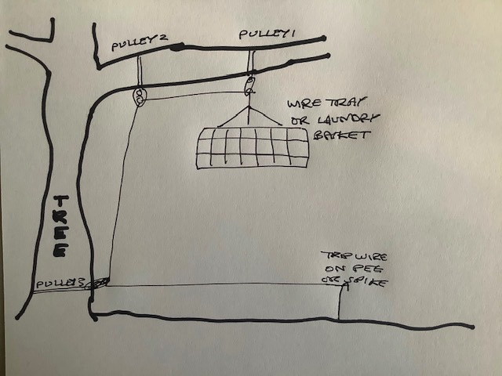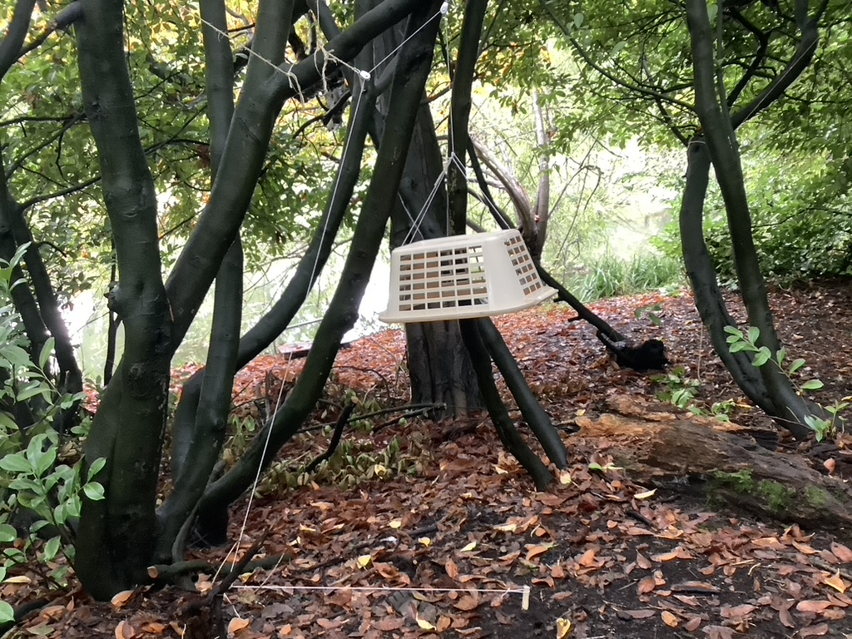

Figure 4 Trap with a small cage or bowl…SAS Survival Manual p 104
Assemble the three bits of wood provided to make the Figure 4 trap… the creature eating the bait knocks out the bottom bar of the 4 which tips the cage onto them.

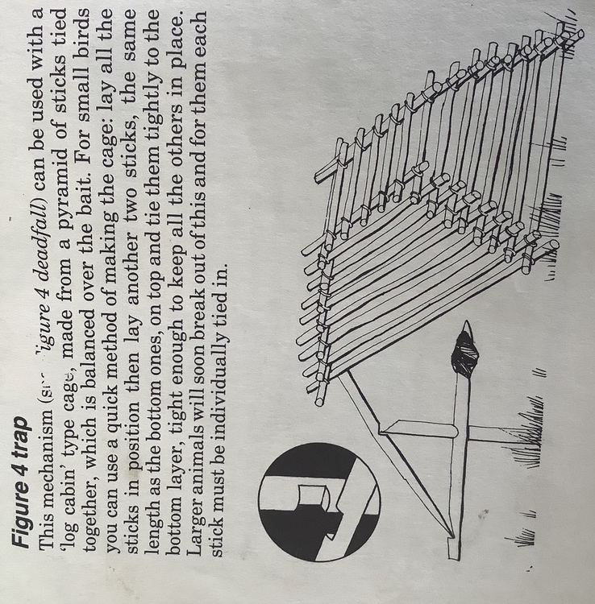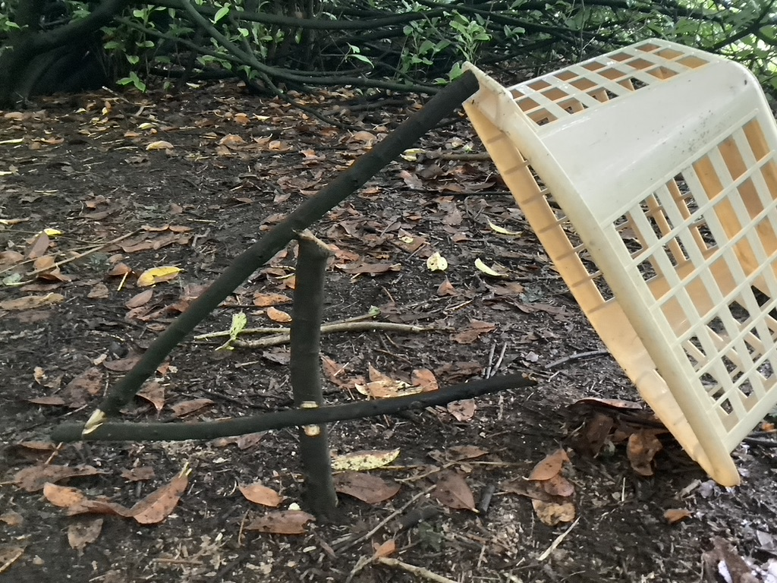
Roller spring snare, SAS Survival Handbook p 98:
Mallet, long tent pegs, snare wire, string, adjustable weight, eg: horseshoes, thin cross bar, small pulley tied to a branch up above… The key here will be adjusting the weight so that the trap does not spring early but does spring when the cross bar is nudged.

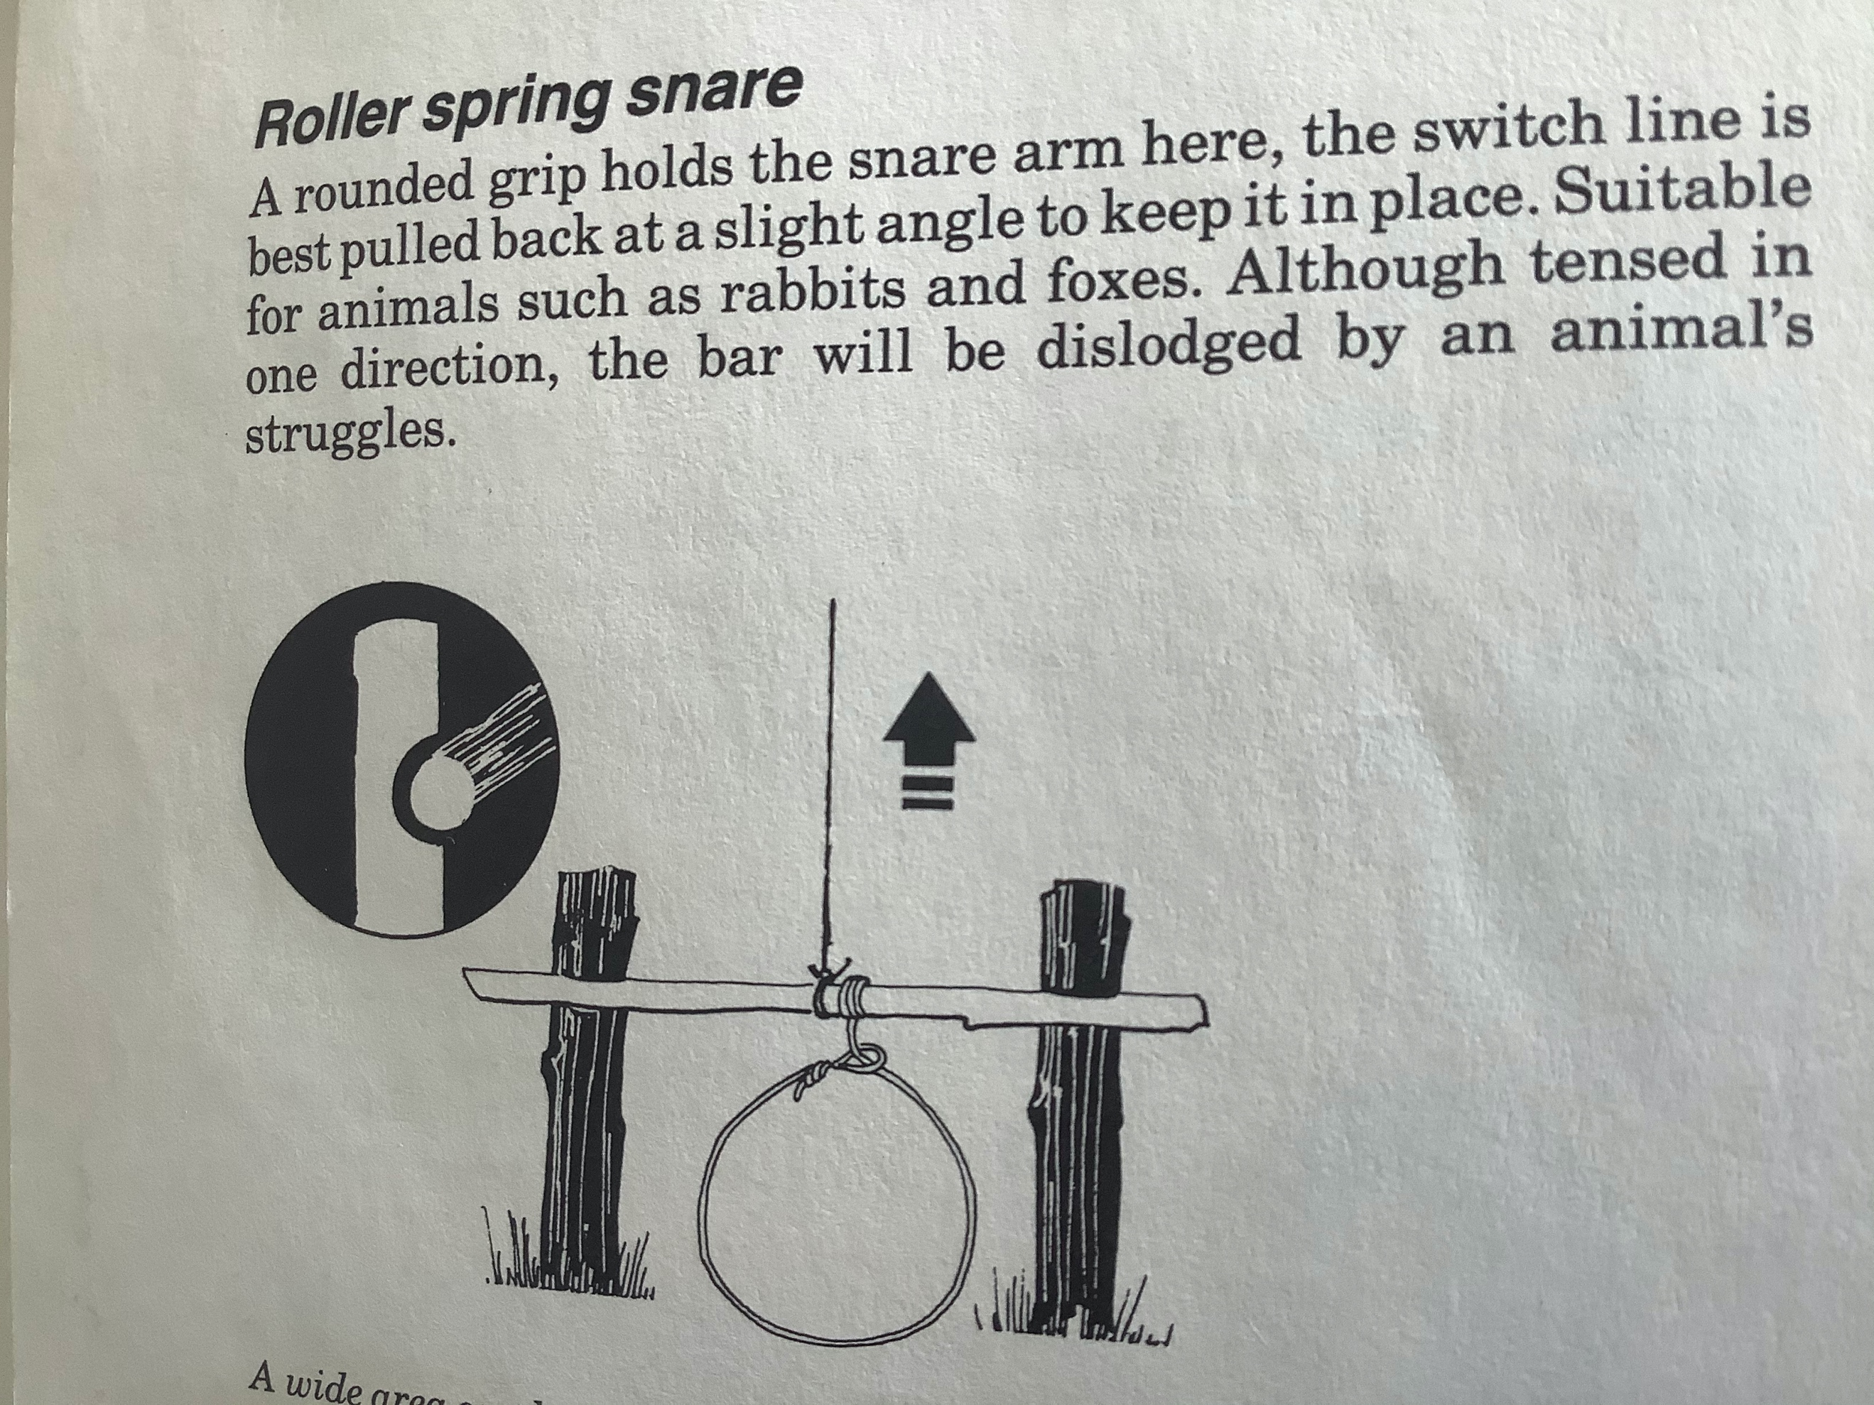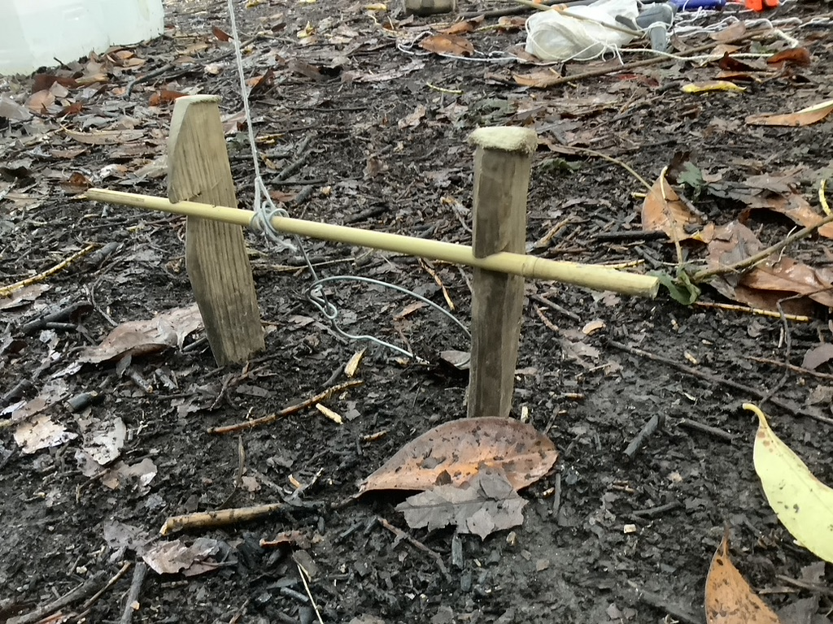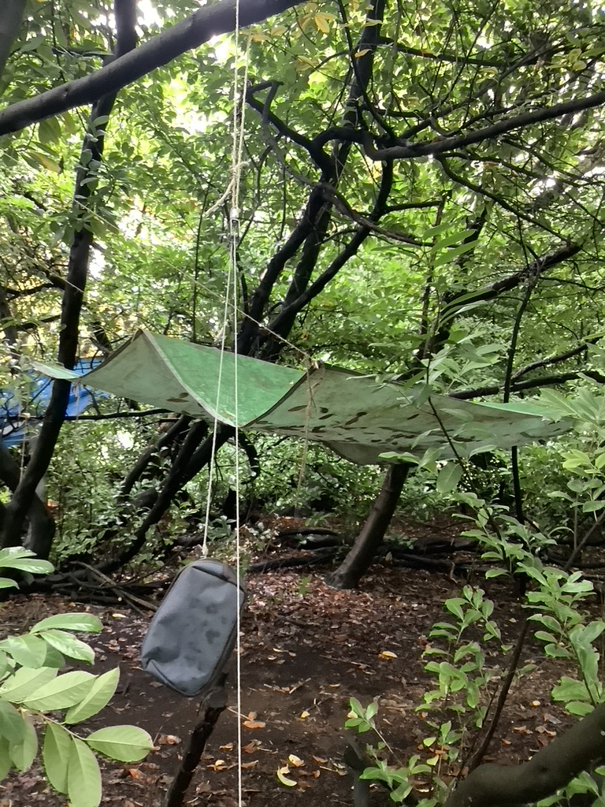

Spring snare using spring of branch in situ.. interlocking tent pegs: SAS Survival Manual, p 97… Mallet, pegs, snare wire, string ball, knife

