Activity | Description | Preparation/ equipment | @home challenge award section https://www.berkshirescouts.org.uk/cubshome/ | Time
Arrival | Welcome the Cubs – usual format |  |  | 5 mins
Lockdown Battleships | Click here for a pdf of the Battleships template.  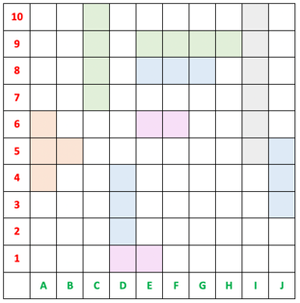  - Cubs take turns to torpedo a square – identified by simple two-character co-ordinates - horizontal then vertical e.g. B7  - Cubs mark off each square as it is torpedoed.  - Invite catastrophic sound-effects and acting from the Cub as each of their ships is sunk  - Who will be the 'Admiral Afloat' as the last few torpedoes are fired?  Unlike the traditional 2-player game, not really practical to track each time you ‘Hit’ an opponent’s ship.  A fun way to instil that map co-ordinates are always expressed as horizontal then vertical: 'you go along the hallway before you go up the stairs' | Email the template to all Cubs in advance – each Cub prints the sheet and positions their fleet before the meeting (as guided on the sheet) | A bit of fun…. while ‘Learning New Skills’ | 30 - 40 mins
Local Maps | Visit www.bing.com/maps and search for your local area and share your computer screen  Start by showing the ‘aerial view’.  - Move the cursor to point to some of your local landmarks and ask the Cubs what they think they are e.g the Scout hut, their school(s), the river, a motorway junction, a car-park…..  Change to the Ordnance Survey view.  - Point out the name of your local town/village and zoom in/out to a familiar area  - Point out how the map is divided up into squares with blue lines.  - Explain how the top is always ‘North’.  - Show the two-digit numbers intermittently along horizontal and vertical lines – moving the map if needed.  - Explain how these help identify different locations on the map - demonstrate the basics of the 4-figure grid reference (referring back to the Battleships grid principles from earlier).  - Discuss some of the other main symbols/features on the map as relevant for your local area e.g. train station, golf course, church, different road colours, lake, beach – you can adjust the level/duration of discussion depending on the time available and experience. | Best to plan ahead - review your maps and select your landmarks and questions in advance. | ‘Learning New Skills’ | 15mins
Close | Encourage the Cubs to look at some more maps with their parents/carers – whether on the computer or paper. |  |  | 5mins

Berkshire Scouts / SD / Sept 2020

