Scout Group New Den Costs

 | BREEAM Report (planning requirement) | £1,980
 | Planning Fees | £1,155
 | Architect | £600
 | Soil Survey | £3,720
 | Bat Survey | £420
 | Project Manager | £1,200
 | Asbestos Survey | £656
 | Asbestos Removal | £3,000
 | Demolition Notice | £228
 | Demolition | £9,600
Various Utilities | Remove/check/resite/restore | £2,402
 | New Den | £178,530
 | New Kitchen | £4,876
 | Shelving for stores | £1200
Total |  | £209,567
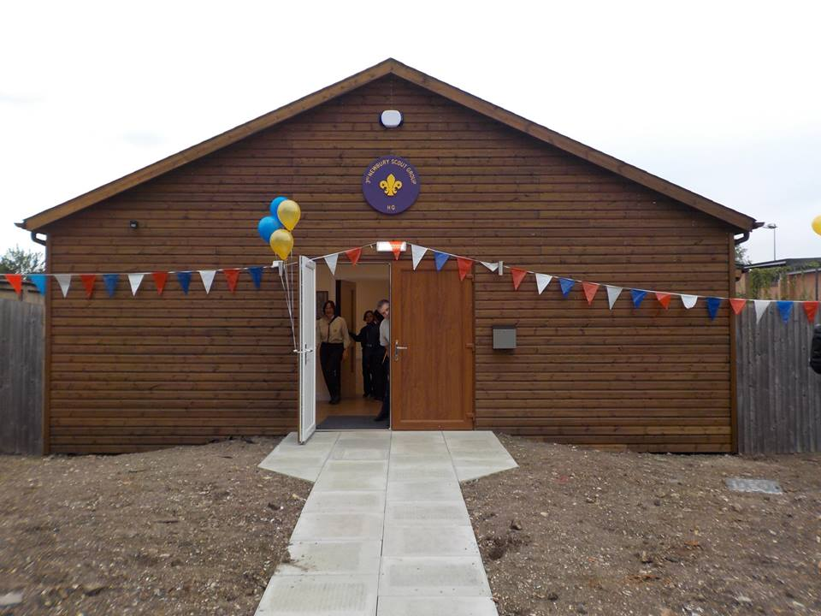

2016

